**Maths**

We will be beginning this term by focusing on consolidating and extending their knowledge, skills and understanding of multiplication and division. We will begin by identifying multiples, factors and prime numbers. They will also continue to revisit many of the learning objectives covered in Term 1 on a regular basis.

The children will continue to practice their maths skills regularly with informal quizzes and test-style activities.

**English**

During the first few weeks of Term 2, our focus will be on poetry. We will be looking at some of the war poetry written at the time of the First World War and finding out about the lives of the famous war poets. The children will be identifying and analysing the features used in this poetry and then go on to write their own poetry.

**Year 5 Term 2 Weeks 1 and 2 2019**

**Learning Journey- Fallen Fields**

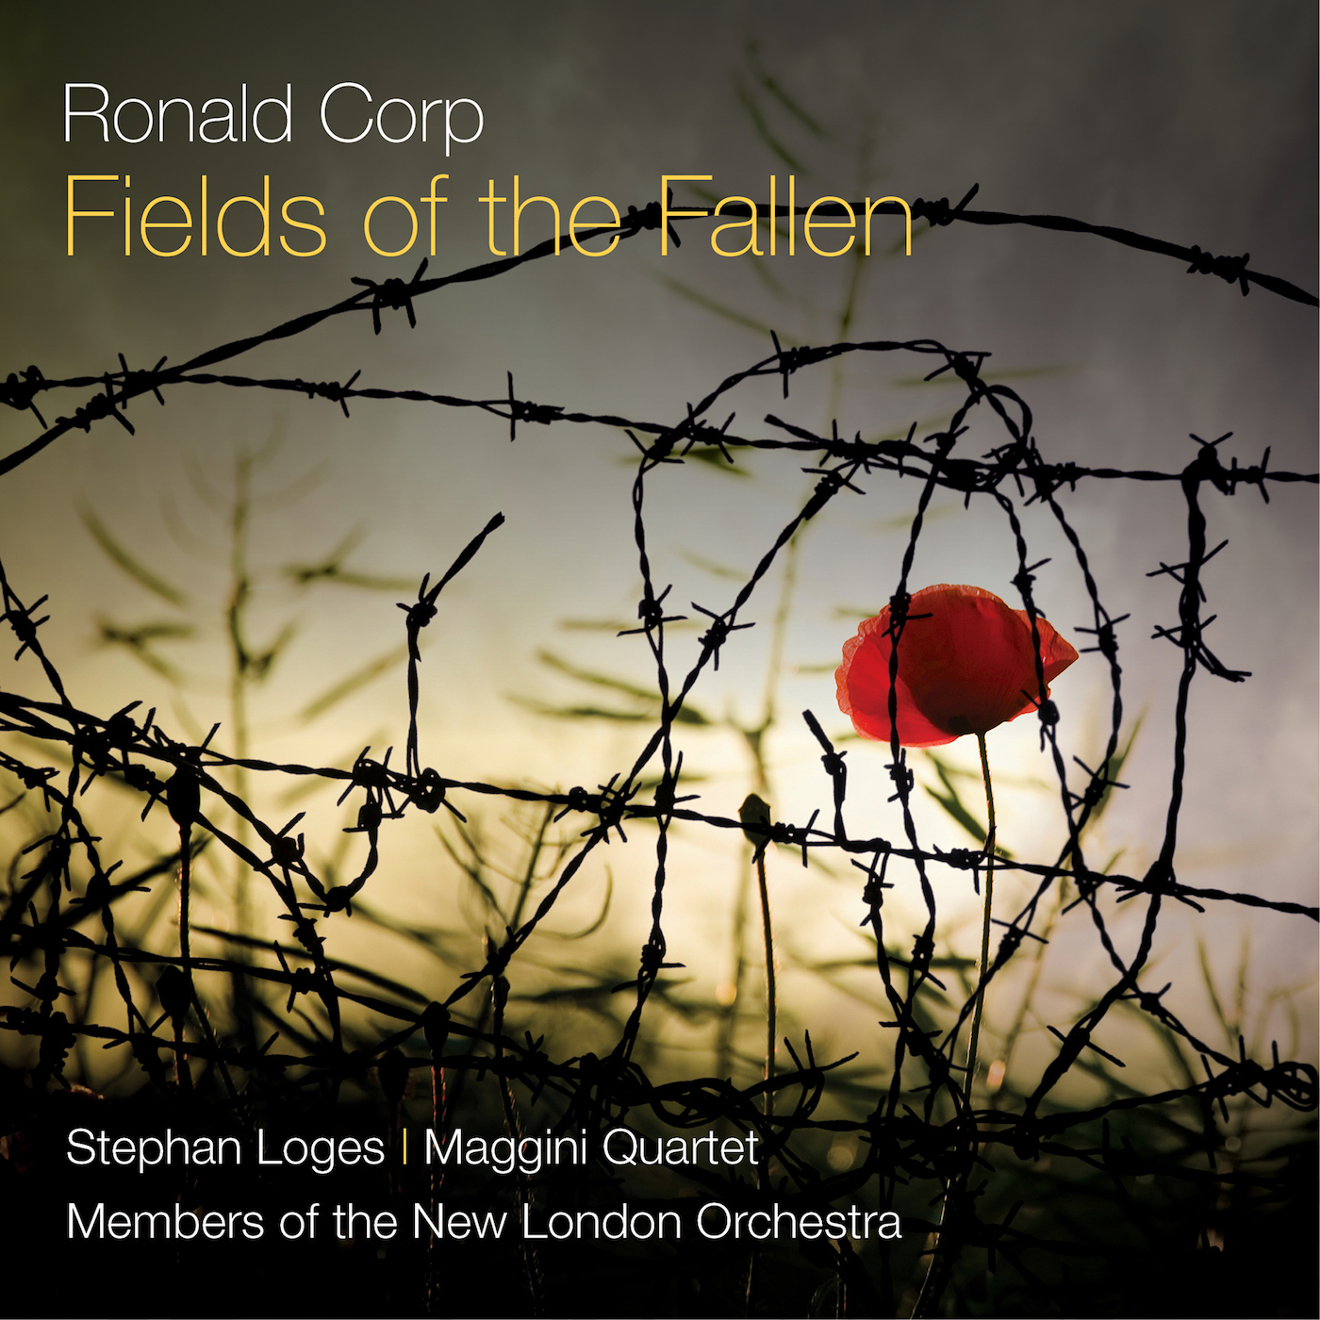

Summary

Indigo class will be exploring the historical topic of ‘Fallen Fields’ throughout the first few weeks of Term 2.

This mini-learning journey will be a cross-curricular exploration, which will aim to inspire the children’s writing and will also involve Indigo Class leading the Remembrance liturgy for the whole school.

**PE and Computing**

As the weather is now colder, please could all children ensure that they have the correct P.E. kit with them for both indoor and outdoor P.E.

Computing will be led by Miss Morley and the work will support children in developing their skills, including the use of coding, developing algorithms and understanding computer networks.

**RE**

Indigo class will be continuing with their Life Choices topic. They will be developing their understanding of the commitment Christians make to follow God and the way in which we live out our individual missions as Holy people through the choices we make.

**Remembrance Assembly**

The Remembrance Assembly will be held on the morning of 11.11.19. All are welcome to attend this thoughtful reflection time and we hope to see you there.

**History**

Children will be learning about the causes and effects of the First World War, going into more depth about significant battles, people and the impact of this devastating war.

**Contact**

If at any point throughout the term you feel there are any issues with your child, anything you feel we need to know or anything fantastic that your child has achieved outside school, please feel free to contact me.

**kwhite@stmarysrc.e-sussex.sch.uk**

**Art**

The children will be engaging with Art during their Enrichment afternoons with Mrs Thorpe.