English

* Phonics for reading and spelling: single sounds, diagraphs
* Letter, sound, phoneme, word, sentence
* Alphabet and letter names
* Finger spaces, full stops and capital letters
* Non-fiction reading and writing
* Science fiction reading and writing
* Handwriting
* Correct formation
* Fine motor skills
* Gross motor skills

Topic ~ Welcome Back Orange Class!

Topic – Amazing Me!

(English, Science, Art, RSE)

* All Are Welcome by Alexandra Penfold
* Friendship - including everyone
* Similarities and differences
* What’s inside my body?
* The Big Science Question: Which of my senses are the most important?

Orange Class Year 1

Curriculum Map Term 1

Mathematics

Place value to 100:

* Counting to and across 100
* Counting forwards and backwards from any 1 or 2-digit number
* Count, read, write numbers to 100
* Find 1 more, 1 less from any 1 or 2-digit number
* Using a number line
* More than, less than, most, least
* Number addition and subtraction
* Using part/whole models

Science & Geography

* Parts of the body
* What’s inside my body?
* Which of my senses are the most important?

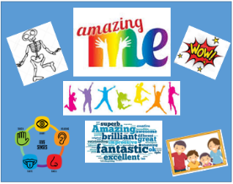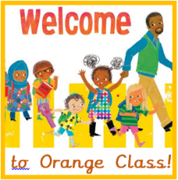

RE

Family:

* Who might be in a family?
* All families are different
* How do families show love and care for each other?

Belonging:

* What groups do we belong to?
* How does it feel to belong to a group?
* How do we welcome some new to our group?

Judaism:

* Abraham
* Moses

Health & Wellbeing

* Families and people who care for me

PE

* Daily PE and fitness sessions

ICT

* Keyboard and mouse skills

Home Learning

* Reading – please hear or share a reading book with your child *everyday!*
* *Common Exception Words* – these are common words that appear often but do not follow the phonic rules, children would benefit enormously from practising reading and writing these words. See St Mary’s website, Curriculum, Year 1
* Additional Home Learning ideas can also be found on the Year 1, term 1 page of St Mary’s website