UPPER KEY

STAGE TWO

**MATHEMATICAL FACTS AND GUIDANCE**





***Pupils should be able to recall, in any order and at speed, all multiplication and corresponding division facts up to 12 x 12.***

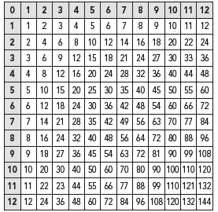

***Conversions between Metric and Imperial Units***

1 litre = 2 pints (more accurately 1 ¾ pints)

4.5 litres = 1 gallon or 8 pints

1 kilogram = 2 lb (more accurately 2.2lb)

30 grams = 1 oz

8 kilometres = 1 mile

***Metric Conversions***

1 kilometre = 1000 metres

1 metre = 100 centimetres or 1000 millimetres

1 centimetre = 10 millimetres

1 kilogram = 1000 grams

1 litre = 1000 millilitres

1 tonne = 1000 kilograms

1 litre = 100 centilitres

1 centilitre = 10 millilitres

**UNITS OF MEASURE**

***30 days hath September,***

***April, June and November,***

***All the rest have 31,***

***except in February alone***

***which has but 28 days clear***

***and 29 in each leap year.***



**Rhymes to help you remember**

*A metre is just 3 feet three*

*It’s longer than a yard you see.*

*Two and a quarter pounds of jam*

*Is round about 1 kilogram.*

*A litre of water’s a pint and three quarters.*

***Time***

1 millennium = 1000 years

1 century = 100 years

1 year = 12 months or 52 weeks or 365 days

1 leap year = 366 days

1 week = 7 days

1 day = 24 hours

1 hour = 60 minutes

1 minute = 60 seconds

**Square Numbers**

1 1x1

4 2x2

9 3x3

16 4x4

25 5x5

36 6x6

49 7x7

64 8x8

81 9x9

100 10x10

**Divisibility Rules**

100 the last 2 digits are 00

25 the last 2 digits are 00, 25, 50 or 75

10 the last digit is 0

2 the last digit is 0, 2, 4, 6 or 8

3 the sum of the digits is divisible by 3

4 the last 2 digits are divisible by 4

5 the last digit is 0 or 5

6 the number is even and divisible by 3

8 the last 3 digits are divisible by 8

9 the sum of the digits is divisible by 9

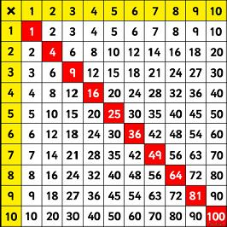

**Place Value**

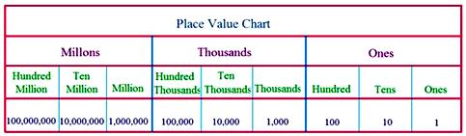

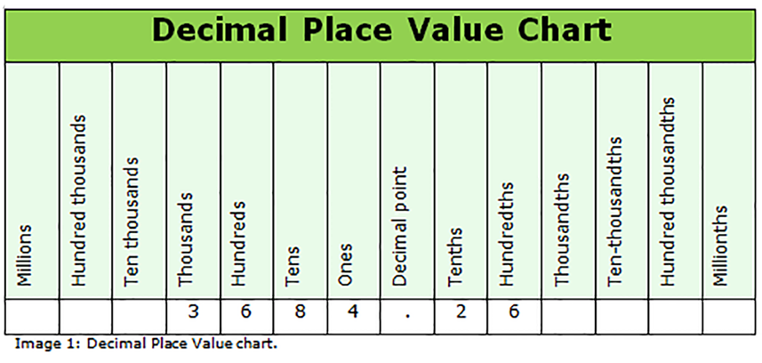

**FRACTIONS DECIMALS PERCENTAGES**

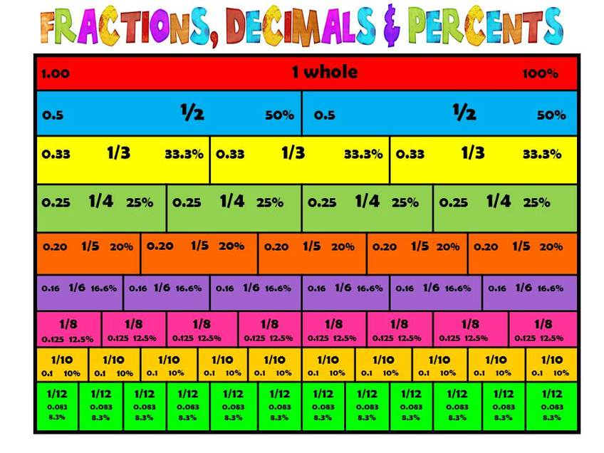

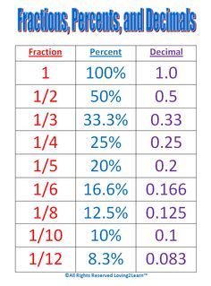

*Home learning supports your child's learning at school and is a great way for them to develop life skills, such as time management and self-discipline. Unfortunately, home learning is also often a source of arguments and unnecessary stress. As teaching methods today are often very different, parents and carers can worry that they will end up confusing their child rather than helping them. Whatever your maths skills, you can still help your child with their home learning.*

**GENERAL TIPS**

**If you don't know something, that's OK.** Try and work out the problem together.

**Set aside some homework time.** Start a homework routine, find a quiet place for your child to work and take away any distractions if possible.

**With younger children, you could set yourself adult "homework" time.** Do 'homework' yourself e.g. shopping list, checking your phone bill. Show them that you are using the skills they're learning.

**Rephrase questions** using things that your child is interested in.

**If they're doing well, praise them for effort.** Say "well done, you've worked so hard", rather than calling them "clever" or praising talent. This helps children learn that their abilities can develop as long as they work hard.

**When they get stuck**, ask them to explain what they've done so far and what they're finding hard. Try and help them work out where they've gone wrong.

**If the home learning is too hard** speak to your child’s teacher.

**With older children, still show interest** but let them be more independent and figure out problems for themselves.

**DISCOVERING NEW METHODS**

**Explain that with maths there is often more than one way to a solve problem.**

**Ask your child to explain their understanding** - get them to teach you!

**QUESTIONS TO ASK**

**How does this connect** **to other topics you're learning at school?**

**What could you use this for in real life?**

***Remember****: Demonstrating positive attitudes to maths is just as important to supporting your child's learning as helping with home learning.*

<http://www.familymathstoolkit.org.uk/helping-with-maths-homework>

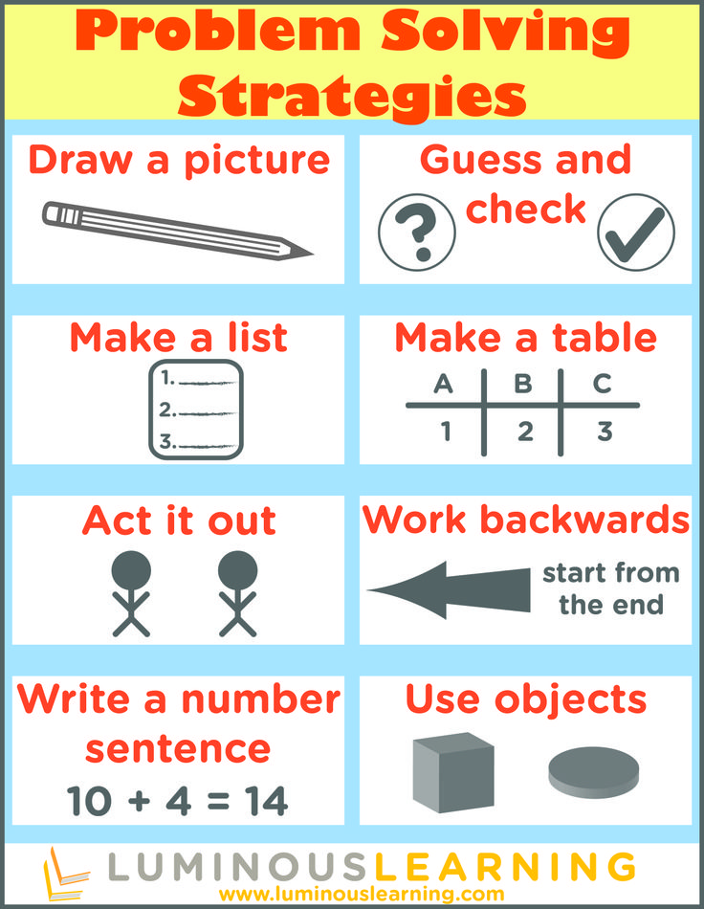

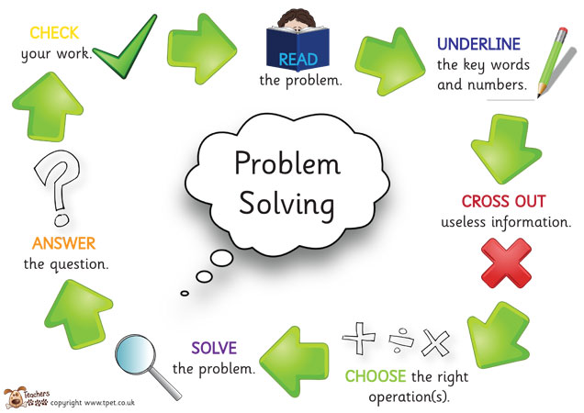

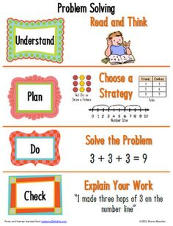

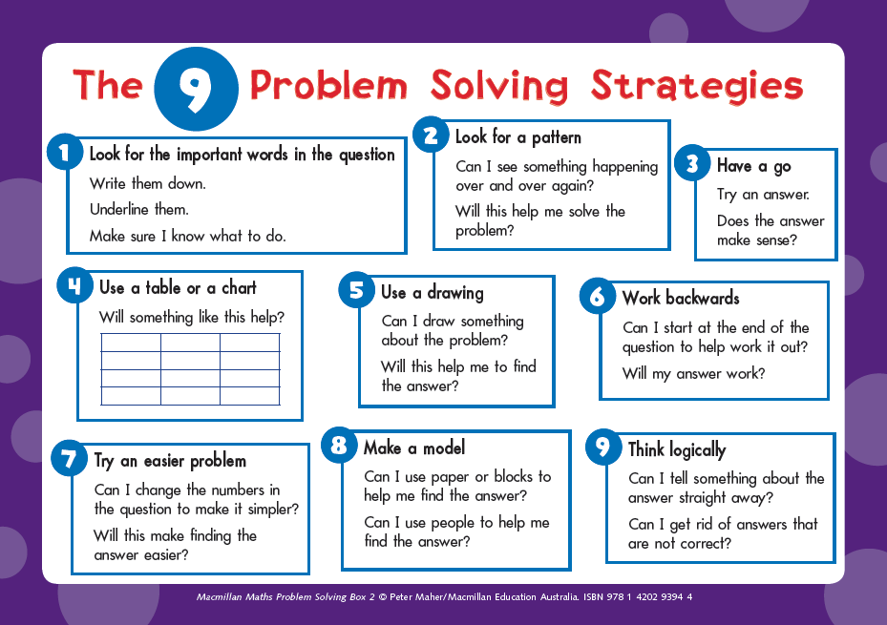

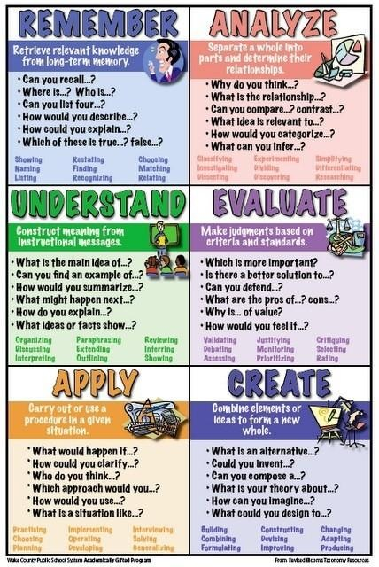

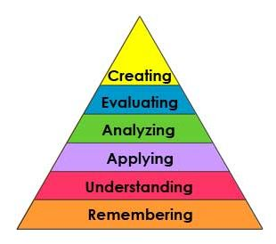

**SUPPORTING HOME LEARNING**