Día de las
muertos

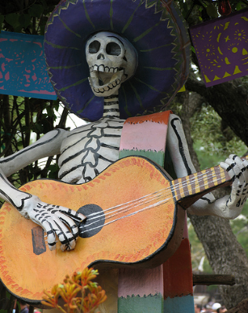
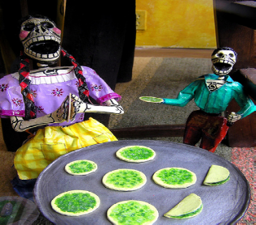
The Mexican fiesta of Día de los Muertos, or Day of the Dead, takes place over the first two days of November. It is a Catholic Christian ritual intermixed with folk culture and going to mass is an essential aspect of this celebration.
Spanish conquistadors introduced All Saints' Day (Día de Todos los Santos) and All Souls' Day ( Día de Todos las almas) to Mexico.The conquered Native Americans took the opportunity to incorporate their own traditions for honoring the dead into these two days. The resulting holiday is a unique mixture of the two cultures.
The fiesta includes spending time in cemeteries, making shrines to the dead, and displaying artistic skulls and skeletons.
However, the occasion is festive, rather than morbid. Death isn't seen as the end of one's life in Mexico but as a natural part of the life cycle. The day of the dead fiesta is not only a chance to remember relatives and friends that have died but to celebrate their life and celebrate being alive.It is about Love not Fear and the fiesta encorporates lots of music, laughter and dancing.
Día de los Muertos is not the Mexican version of Halloween. Mexicans have celebrated the Day of the Dead since the year 1800 B.C !
Whilst Day of the Dead and Halloween are both associated with All Saints' and All Souls' Days, their tones couldn't be more different. Halloween's images of skeletons and spirits emphasize the spooky, gruesome, and macabre. On Day of the Dead, the focus isn't on threatening spooks and gouls, it's on celebrating with one's family—alive and dead—and remembering those who are no longer alive. It's on seeing death as another stage following life, not something to be faced with fear.
It is not a “strange” ritual. It is very similar to going to a grave and leaving flowers or stuffed animals, lighting a candle to remember the deceased.
It is not a sad ritual. It’s a day of happiness because they are remembering loved ones.



